1. INTRODUCTION
1.1 Topic Introduction
Music plays an important role in human life by providing entertainment, relaxation, and emotional connection. With the advancement of web technologies and the widespread use of the internet, the way people access and listen to music has changed significantly. Traditional methods such as downloading songs or using offline media are gradually being replaced by online music platforms.
The Music Hub Application is a web-based music platform designed to provide users with easy access to music through a single centralized system. The application allows users to browse, play, and manage music content using a simple and user-friendly interface. It is developed using HTML, CSS, and JavaScript for the frontend and Django for the backend, ensuring smooth interaction between the user and the system.
This project focuses on applying fundamental web development concepts and backend integration to build a functional music application. The Music Hub Application demonstrates how modern web technologies can be used to create interactive and dynamic web applications suitable for real-world use.

1.2 Abstract
The Music Hub Application is a web-based music management and streaming system developed to provide users with an organized and efficient way to access music content. The system enables users to register, log in, browse available songs, create playlists, and listen to music online. The application is designed with a clear separation between frontend and backend components to ensure better performance and maintainability. The application also reflects real-world music streaming concepts, making it useful for understanding industry-level web application development.
The frontend of the application is developed using HTML, CSS, and JavaScript to create responsive and interactive web pages. The backend is implemented using the Django framework, which handles user authentication, database operations, and business logic. This project follows standard software development practices and aims to provide hands-on experience in full-stack web application development.

1.3 Existing System and Need for System
In the existing system, users depend on multiple music platforms or offline storage devices to listen to music. Many available music applications require paid subscriptions, consume high system resources, or provide limited control over music organization. Additionally, some systems lack personalization and flexibility in managing playlists and user preferences.
The need for the Music Hub Application arises from the requirement for a simple, lightweight, and centralized music platform. The proposed system allows users to manage their music efficiently while providing easy navigation and accessibility. It also offers better control over data management and user interaction, making it suitable for educational and small-scale applications.
1.4 Scope of System
The scope of the Music Hub Application defines the boundaries and functionality of the system. The application is designed to perform the following operations:
- User registration and login functionality
- Browsing and searching available music tracks
- Playing music through a web-based interface
- Creating and managing playlists
- Admin functionality for adding and managing music content
The system is intended for academic purposes and small user groups. However, the design allows future enhancements and scalability if required.
1.5 Operating Environment
The Music Hub Application operates in a web-based environment and requires the following hardware and software resources:
- Frontend Technologies: HTML5, CSS3, JavaScript
- Backend Technology: Django (Python)
- Database: SQLite / MySQL
- Operating System: Windows or Linux
- Web Browser: Google Chrome, Mozilla Firefox
The application can be accessed using any modern web browser with an active internet connection.
1.6 Brief Description of Technology Used (Architecture etc.)
The Music Hub Application is developed using modern web technologies that follow a structured and modular approach. The application is based on a client–server architecture, where the frontend and backend operate independently while communicating with each other through HTTP requests and responses.
The frontend of the application is developed using HTML, CSS, and JavaScript. HTML is used to structure the web pages, CSS is used to design and style the user interface, and JavaScript is used to add interactivity such as dynamic content loading, form validation, and media controls. These technologies together ensure a responsive and user-friendly interface for the end user.
The backend of the application is developed using the Django framework, which is a high-level Python web framework. Django is responsible for handling user authentication, business logic, database interactions, and secure request processing. It provides built-in features such as URL routing, form handling, and authentication mechanisms, which enhance the security and reliability of the system. Django was selected due to its simplicity, security features, and suitability for rapid application development.
The application follows Django’s Model–View–Template (MVT) architecture. The Model represents the database structure and manages data-related logic such as storing user details, music information, and playlist data. The View processes user requests and controls the flow of data between the model and the template. The Template layer is responsible for rendering dynamic content on the web pages using HTML and Django template tags.
The database used in the system stores structured data such as user profiles, song details, and playlist information. Audio files are stored on the server and accessed through the application interface. This separation of data and application logic improves system maintainability and performance.
Overall, the chosen technology stack ensures simplicity, scalability, and ease of development, making the Music Hub Application suitable for academic learning and future enhancement.

2. PROPOSED SYSTEM
2.1 Feasibility Study
A feasibility study is conducted to evaluate whether the proposed system is practical, efficient, and achievable within the given constraints. For the Music Hub Application, the feasibility study ensures that the project can be successfully developed and implemented using available resources, technology, and time. The feasibility analysis is divided into the following categories:

- Technical Feasibility -
The Music Hub Application is technically feasible as it uses widely accepted and well-supported technologies such as HTML, CSS, JavaScript, and Django. These technologies are easy to learn and implement, especially for academic projects. Django provides built-in features for database handling, authentication, and security, reducing development complexity. The required hardware and software resources are readily available, making the system technically achievable.

- Economic Feasibility -
The proposed system is economically feasible since it uses open-source tools and frameworks. There is no requirement for expensive software licenses or specialized hardware. The development cost is minimal, making the project suitable for students and educational institutions. Maintenance and operational costs are also low.

- Operational Feasibility -
The system is designed to be user-friendly and easy to operate. Users can access the application through a web browser without requiring technical knowledge. The interface is simple, and navigation is intuitive, ensuring smooth interaction for both administrators and users. Minimal training is required to use the system effectively.

2.2 Objectives of Proposed System
The primary objective of the Music Hub Application is to provide a centralized and efficient platform for managing and streaming music content. The system aims to simplify music access while offering essential features for users and administrators. The key objectives of the proposed system are as follows:
- To develop a web-based music application using modern web technologies
- To allow users to register, log in, and access music content securely
- To enable users to browse, play, and organize music tracks
- To provide playlist creation and management functionality
- To offer administrative control for managing users and music data
2.3 Users of System
The Music Hub Application is designed to support different types of users, each with specific roles and responsibilities. The users of the system are categorized as follows:
- Administrator -
The administrator has full control over the system. The admin is responsible for managing music content, including adding, updating, and deleting songs. The administrator also manages user accounts and ensures the smooth functioning of the application.
- Registered Users -
Registered users can log in to the system and access full functionality. They can browse music tracks, play songs, create and manage playlists, and personalize their music experience according to their preferences.
- Guest Users -
Guest users can access limited features of the application without logging in. They can view available music content but have restricted access to advanced features such as playlist creation.

CHAPTER 3: ANALYSIS AND DESIGN
3.1 System Requirements (Functional and Non-Functional Requirements)
System requirements define the capabilities and constraints of the Music Hub Application. These requirements help in understanding what the system should do and how it should perform. The requirements are classified into functional and non-functional requirements.
3.1.1 Functional Requirements
Functional requirements specify the core features and operations that the system must perform. The functional requirements of the Music Hub Application are as follows:
- The system shall allow users to register and create an account.
- The system shall provide secure login and logout functionality.
- The system shall allow users to browse the list of available music tracks.
- The system shall enable users to play music through the web interface.
- The system shall allow registered users to create, update, and delete playlists.
- The system shall allow the administrator to add, update, and remove music content.
- The system shall store user and music data securely in the database.
These functional requirements ensure smooth interaction between users and the application.
3.1.2 Non-Functional Requirements
Non-functional requirements define the quality attributes and performance standards of the system. The non-functional requirements of the Music Hub Application include:
- Performance: The system should load pages and play music with minimal delay.
- Usability: The user interface should be simple, intuitive, and easy to navigate.
- Security: User data and login credentials must be protected using secure authentication mechanisms.
- Scalability: The system should support future expansion such as additional users or music content.
- Reliability: The application should function consistently without unexpected failures.
- Maintainability: The system should be easy to update and modify when required.

3.2 Database (Structured, Non-Structured)
A database is an essential component of the Music Hub Application, as it is responsible for storing and managing all system-related data. The database ensures data consistency, integrity, and easy retrieval of information required by the application.
The Music Hub Application uses both structured and non-structured data:
- Structured Data
Structured data refers to data that is organized in a predefined format and stored in relational tables. In the Music Hub Application, structured data is stored in a relational database such as SQLite or MySQL. This data includes:
- User details such as username, email, and password
- Music information such as song title, artist, genre, and duration
- Playlist details including playlist name and associated user
- Relationships between users, playlists, and music tracks
Django’s Object Relational Mapping (ORM) is used to interact with the database. The ORM simplifies database operations by allowing developers to work with database records using Python objects instead of writing complex SQL queries.
- Non-Structured Data
Non-structured data does not follow a fixed table format. In the Music Hub Application, non-structured data mainly consists of audio files (music tracks) and media-related content. These files are stored on the server and accessed through file paths stored in the database.
The separation of structured and non-structured data improves system performance and makes data management more efficient. Structured data ensures organized storage of records, while non-structured data allows flexible handling of multimedia content.

3.3 Table Structure
The table structure defines how data is organized and stored in the database. Proper table design ensures efficient data storage, retrieval, and management. In the Music Hub Application, the database consists of multiple tables that represent different entities of the system.
The major tables used in the system are described below:
1. User Table
The User table stores information related to registered users of the application. This table is managed using Django’s built-in authentication system.
Field Name | Data Type | Description
User_ID | Integer | Unique identifier for each user
Username | Varchar | User login name
Email | Varchar | User email address
Password | Varchar | Encrypted user password
Role | Varchar | User role (Admin/User)

2. Music Table
The Music table stores details of music tracks available in the application.
Field Name | Data Type | Description
Music_ID | Integer | Unique identifier for each song
Title | Varchar | Song title
Artist | Varchar | Artist name
Genre | Varchar | Music genre
Duration | Time | Length of the song
File_Path | Varchar | Location of audio file

3. Playlist Table
The Playlist table stores information about user-created playlists.
Field Name | Data Type | Description
Playlist_ID | Integer | Unique playlist identifier
Playlist_Name | Varchar | Name of the playlist
User_ID | Integer | Associated user

4. Playlist_Music Table
This table manages the relationship between playlists and music tracks.
Field Name | Data Type | Description
ID | Integer | Unique identifier
Playlist_ID | Integer | Reference to playlist
Music_ID | Integer | Reference to music track

The table structure follows relational database principles, ensuring data integrity and eliminating redundancy. Relationships between tables allow efficient data retrieval and smooth application functionality.
3.4 Use Case Diagrams
Use case diagrams are used to represent the interaction between users and the system. They help in understanding the functional requirements of the Music Hub Application by illustrating how different users interact with various system features.
In the Music Hub Application, the use case diagram identifies the main actors and their interactions with the system. The primary actors of the system are Administrator, Registered User, and Guest User.

Administrator Use Cases
The administrator interacts with the system to manage overall functionality. The main use cases for the administrator include:
- Login to the system
- Add new music tracks
- Update existing music details
- Delete music tracks
- Manage user accounts
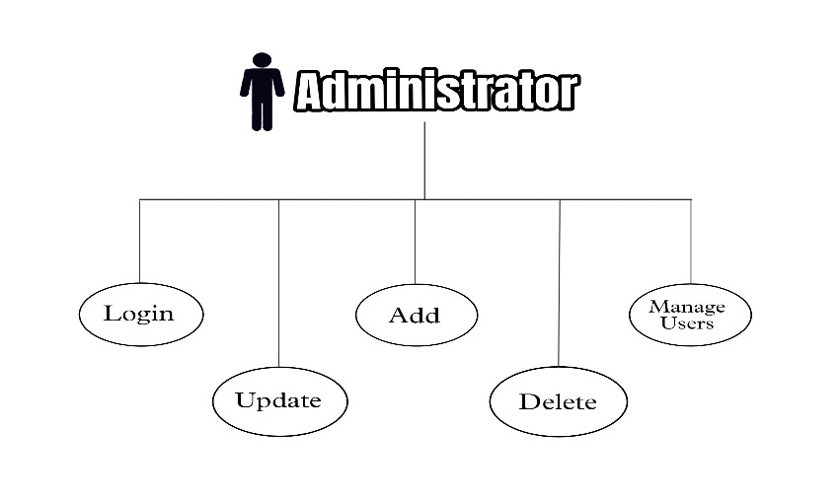
Registered User Use Cases
Registered users have access to most features of the application. Their main use cases include:
- Register and log in to the system
- Browse available music tracks
- Play music
- Create and manage playlists
- Logout from the system
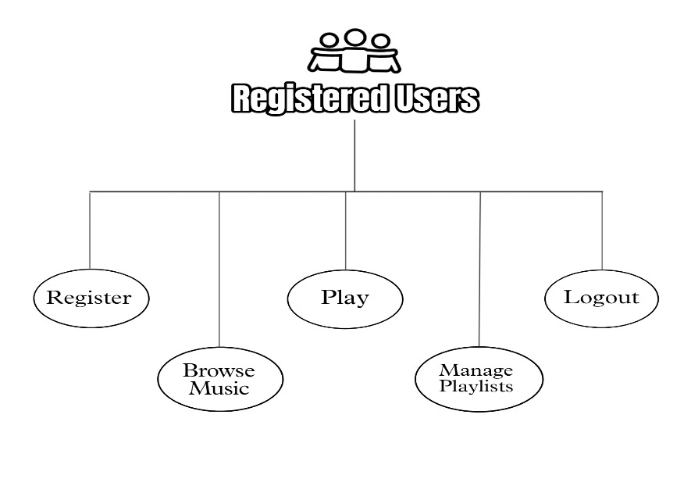
Guest User Use Cases
Guest users have limited access to the system. Their use cases include:
- View available music tracks
- Access basic information about the application
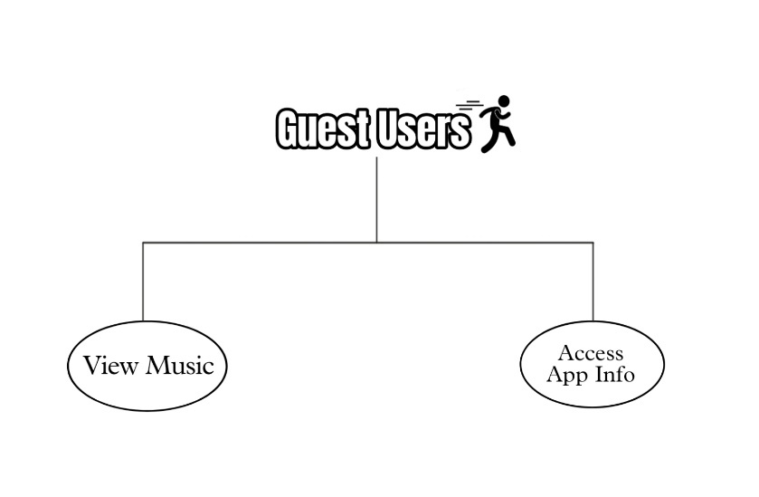

3.5 Class Diagram
Main Classes for Music Hub Application:
Class | Attributes | Methods
User | userID, username, email, password, userType | login(), logout()
Administrator (inherits User) | adminID | addMusic(), updateMusic(), deleteMusic(), manageUsers()
RegisteredUser (inherits User) | playlistList | createPlaylist(), managePlaylist(), playMusic(), browseMusic()
GuestUser (inherits User) | - | browseMusic(), viewAppInfo()
MusicTrack | trackID, title, artist, album, genre, duration | play(), updateDetails()
Playlist | playlistID, name, trackList | addTrack(), removeTrack(), playPlaylist()
Relationships:
- Inheritance: Administrator, RegisteredUser, GuestUser inherit User.
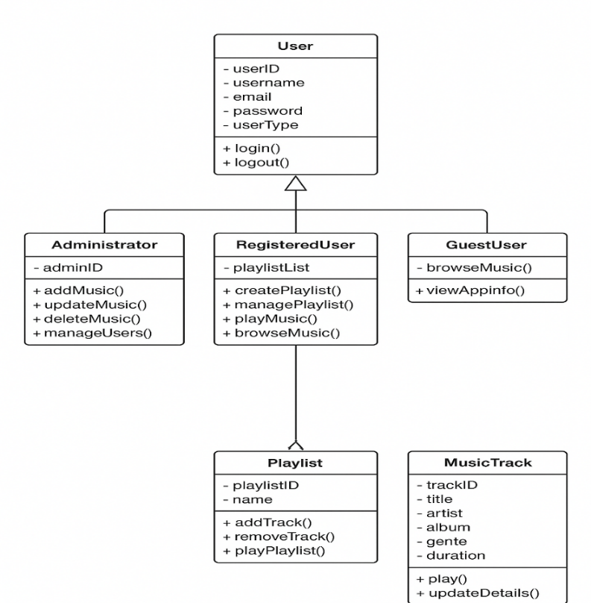
3.6 Activity Diagram
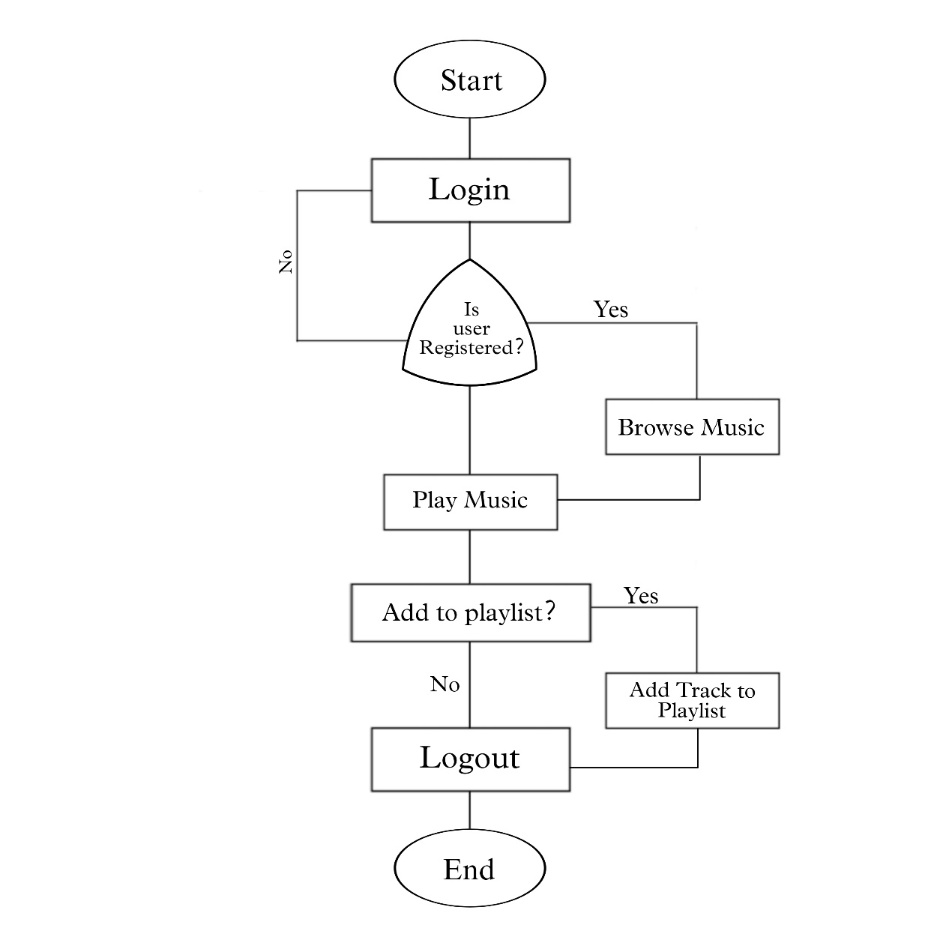
3.7 Deployment Diagram
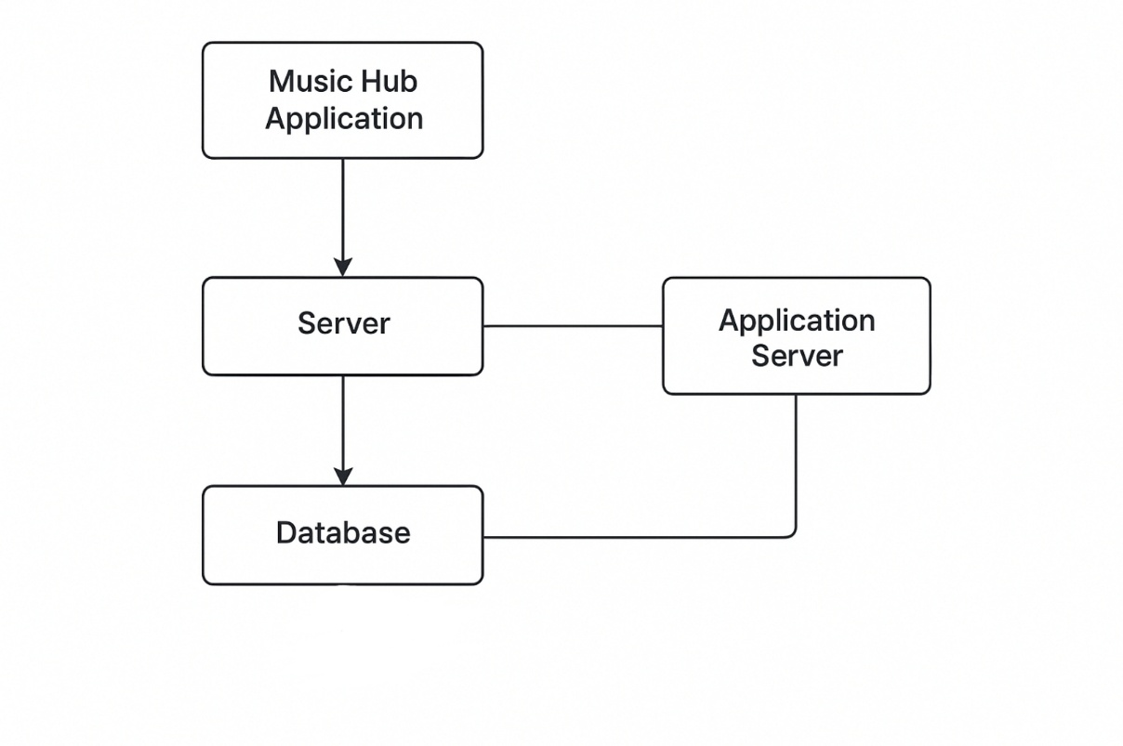
3.8 Module Hierarchy Diagram
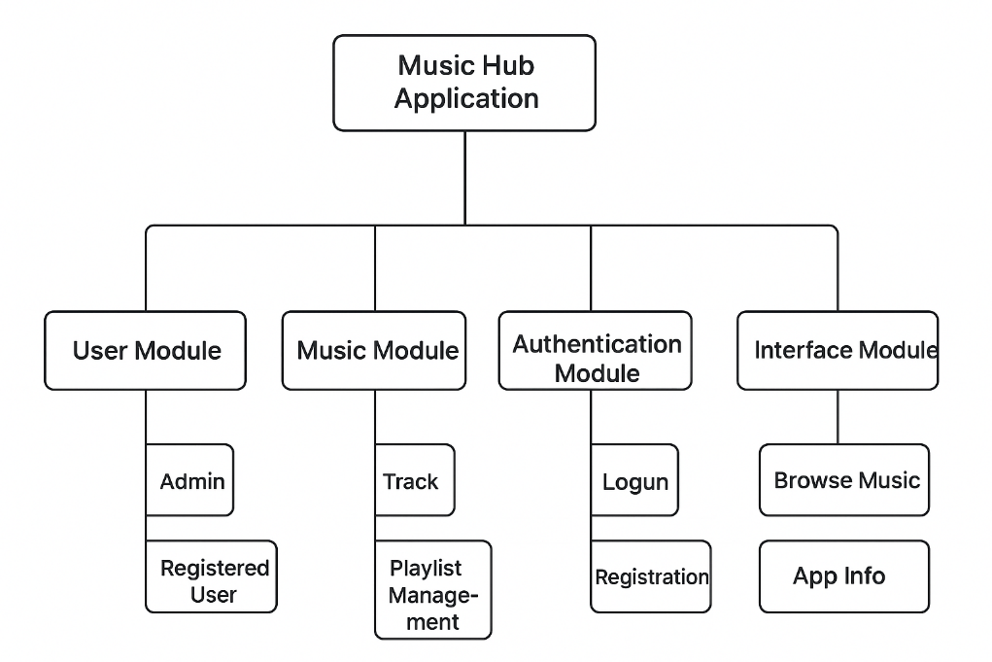
3.9 Sample Input & Output Screens
Main Page :
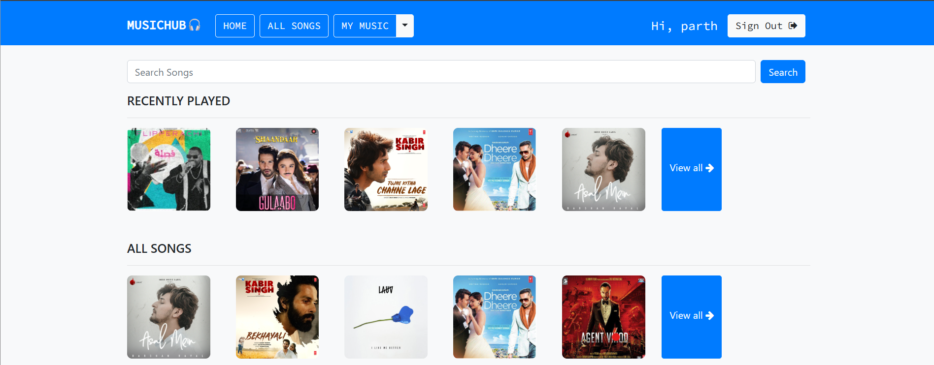
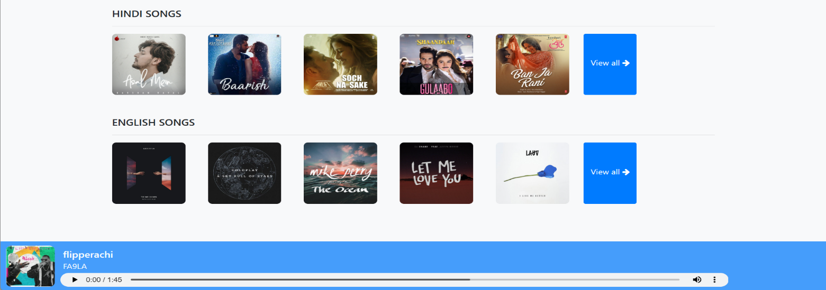
All Songs List :
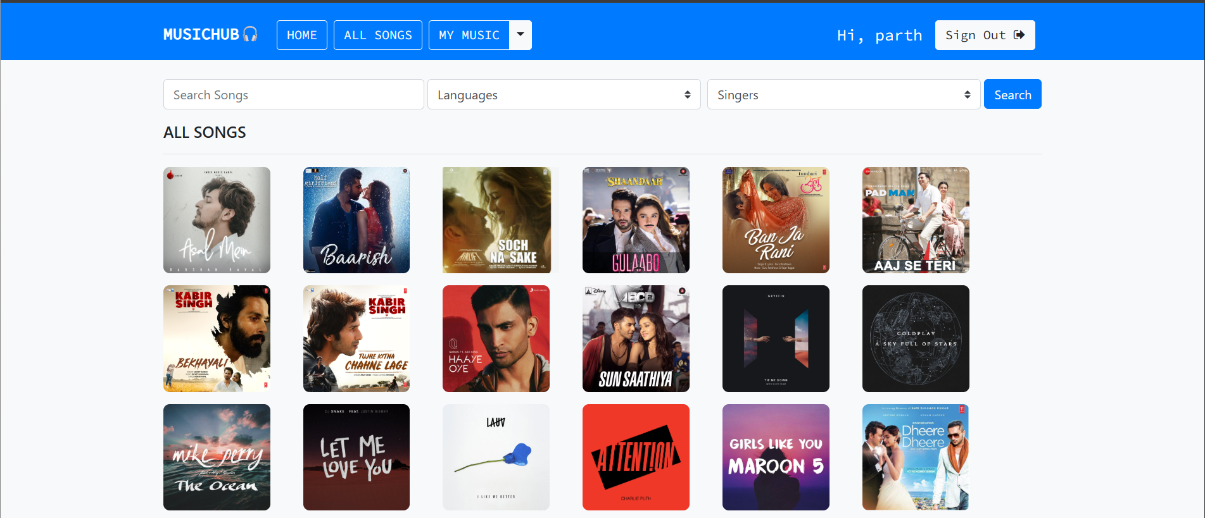

My Music Page :

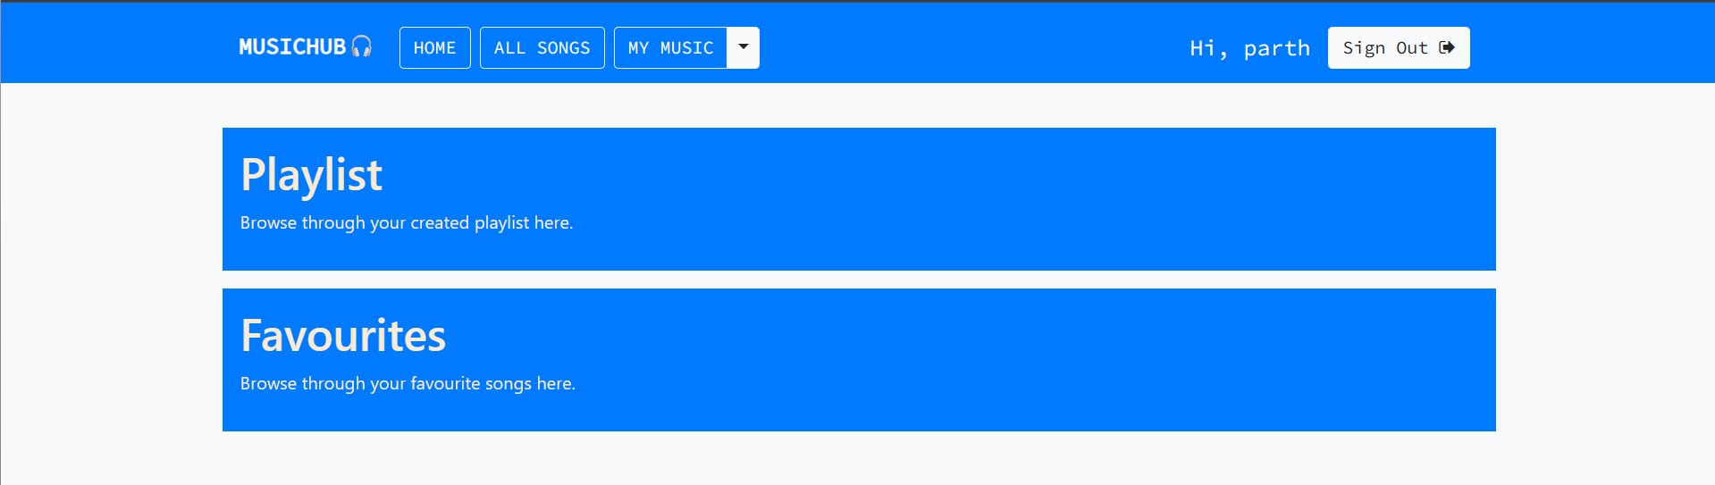

Playlist Page :
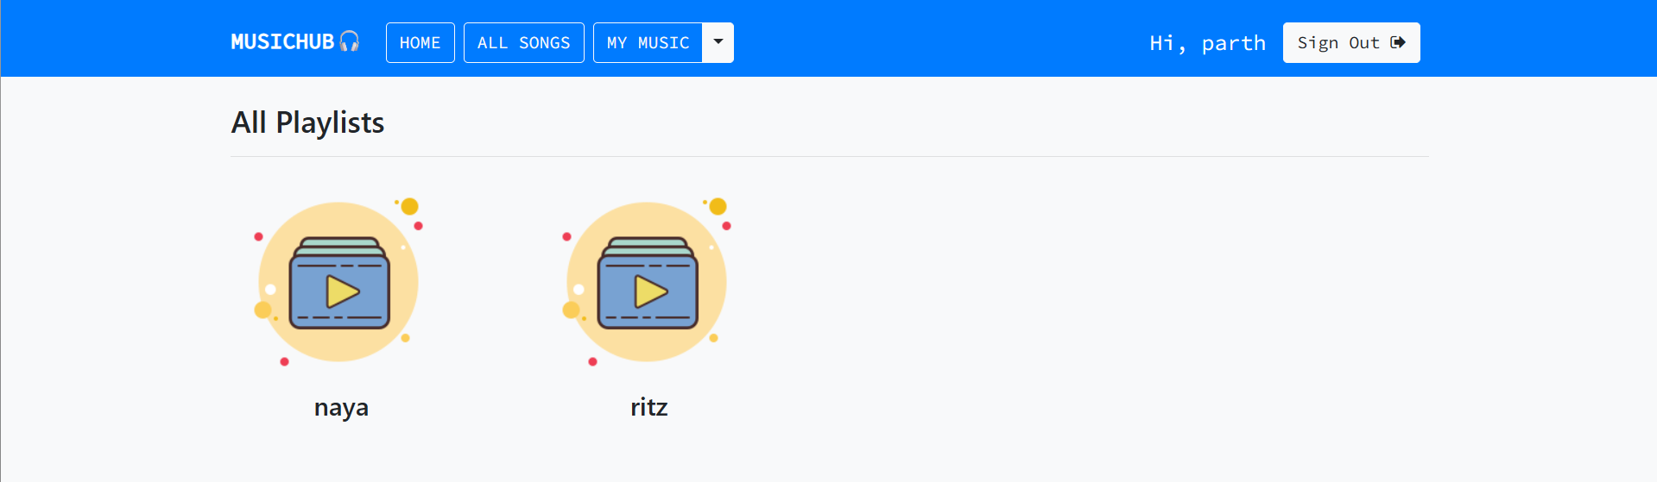
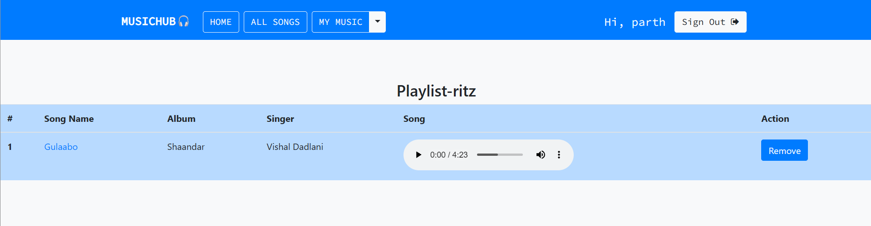
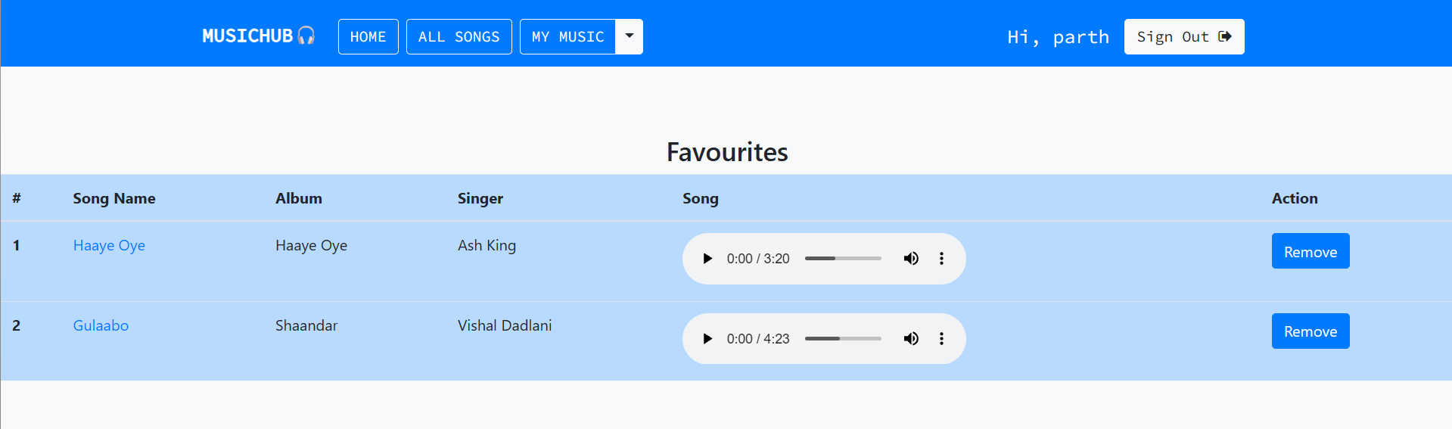
Sign Up Page :
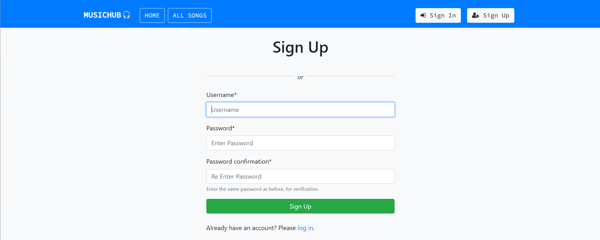
Login Page :
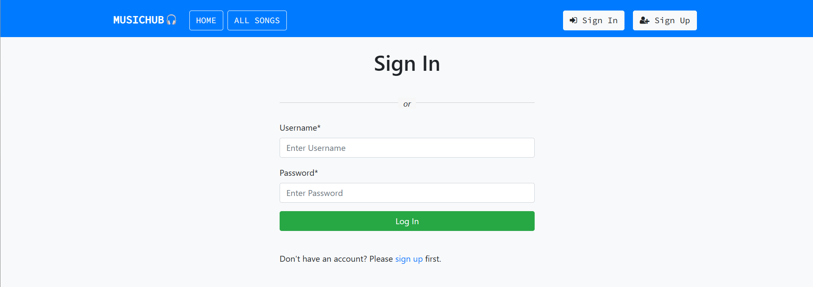
Admin Panel :
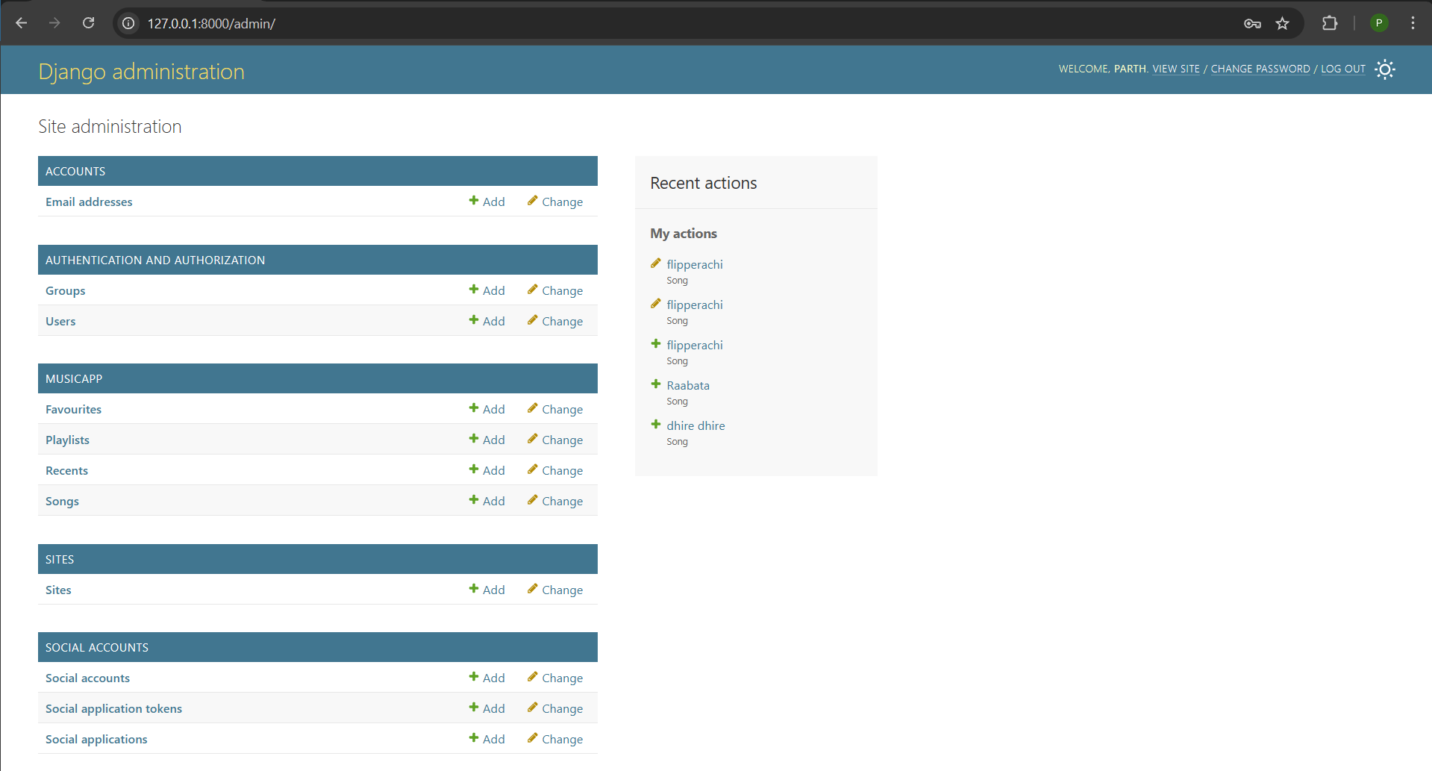

4. CODING
4.1 Coding Snippets
This chapter describes the implementation details of the proposed system. The system is developed using HTML, CSS, JavaScript for the frontend and Django for the backend. Django follows the Model–View–Template (MVT) architecture, which helps in separating application logic, user interface, and database operations.
The following sections present important code snippets used in the development of the system.
4.1.2 Django Model Code
Models define the database structure of the application. Django uses ORM (Object Relational Mapping) to interact with the database.
from django.db import models
from django.contrib.auth.models import User
class Record(models.Model):
title = models.CharField(max_length=100)
description = models.TextField()
created_at = models.DateTimeField(auto_now_add=True)
user = models.ForeignKey(User, on_delete=models.CASCADE)
def __str__(self):
return self.title
Explanation:
• models.Model is the base class for all models.
• CharField and TextField define text data.
• ForeignKey creates a relationship with the User table.
• auto_now_add stores record creation time automatically.
4.1.3 Django Forms Code
Forms are used to handle user input and validation.
from django import forms
from .models import Record
class RecordForm(forms.ModelForm):
class Meta:
model = Record
fields = ['title', 'description']
Explanation:
• ModelForm automatically creates form fields from the model.
• Reduces manual coding and improves validation.
4.1.4 Django Views Code
Views handle the business logic and process user requests.
from django.shortcuts import render, redirect
from .models import Record
from .forms import RecordForm
from django.contrib.auth.decorators import login_required
@login_required
def dashboard(request):
records = Record.objects.filter(user=request.user)
return render(request, 'dashboard.html', {'records': records})
@login_required
def add_record(request):
if request.method == 'POST':
form = RecordForm(request.POST)
if form.is_valid():
record = form.save(commit=False)
record.user = request.user
record.save()
return redirect('dashboard')
else:
form = RecordForm()
return render(request, 'add_record.html', {'form': form})
Explanation:
• login_required ensures only authenticated users can access pages.
• render() loads HTML templates.
• redirect() navigates users after successful operations.
4.1.5 URL Configuration
URLs map requests to views.
from django.urls import path
from . import views
urlpatterns = [
path('', views.dashboard, name='dashboard'),
path('add/', views.add_record, name='add_record'),
]
Explanation:
• Each URL is linked to a corresponding view.
• Makes navigation structured and readable.
4.1.6 HTML Template Code
HTML templates define the user interface.
<!DOCTYPE html>
<html>
<head>
<title>Dashboard</title>
</head>
<body>
<h2>My Records</h2>
<a href="{% url 'add_record' %}">Add Record</a>
<ul>
{% for record in records %}
<li>{{ record.title }} - {{ record.created_at }}</li>
{% endfor %}
</ul>
</body>
</html>

Explanation:
• Django Template Language (DTL) is used.
• {% for %} loop displays records dynamically.
4.1.7 CSS Code
CSS improves the visual appearance of the application.
body {
font-family: Arial, sans-serif;
background-color: #f4f4f4;
}
h2 {
color: #333;
}
a {
text-decoration: none;
color: blue;
}
Explanation:
• Controls layout, fonts, and colors.
• Improves user experience.

4.1.8 JavaScript Code
JavaScript is used for client-side validation.
function validateForm() {
let title = document.getElementById("title").value;
if (title === "") {
alert("Title cannot be empty");
return false;
}
return true;
}
Explanation:
• Prevents empty submissions.
• Improves responsiveness without server reload.
4.1.9 Authentication Code
Django provides built-in authentication.
from django.contrib.auth import authenticate, login, logout
def user_login(request):
if request.method == 'POST':
user = authenticate(
username=request.POST['username'],
password=request.POST['password']
)
if user:
login(request, user)
return redirect('dashboard')
return render(request, 'login.html')
Explanation:
• authenticate() checks credentials.
• login() creates a session for the user.
4.1.10 Database Migration Code
python manage.py makemigrations
python manage.py migrate
Explanation:
• Converts models into database tables.
• Ensures database consistency.

5. TESTING
Testing is an important phase in the software development life cycle. It ensures that the Music Hub Application functions correctly, meets user requirements, and is free from major errors. The testing process helps identify defects and improves the overall quality, reliability, and performance of the system.
5.1 Test Strategy
The test strategy defines the overall approach used to test the Music Hub Application. Manual testing is primarily used to verify the correctness of system functionality, user interface behavior, and data processing. The testing strategy focuses on:
- Verifying each module independently
- Ensuring proper integration between frontend and backend
- Validating user inputs and system responses
- Checking security and access control features
Different test cases are executed for login, music playback, playlist management, and admin operations to ensure that the system behaves as expected under normal and abnormal conditions.
5.2 Unit Test Plan
Unit testing involves testing individual components or modules of the system to ensure they function correctly. Each unit is tested independently before integrating it with other modules. The following modules are tested under the unit test plan:
- User registration and login module
- Music management module
- Playlist creation and management module
- Admin operations module
Unit testing ensures that each module performs its intended function and helps in early detection of errors, reducing overall system failure.

5.3 Acceptance Test Plan
Acceptance testing is performed to verify whether the Music Hub Application meets the specified requirements and is ready for use. This testing is carried out from the user’s perspective. The acceptance test plan includes:
- Verifying successful user registration and login
- Ensuring music tracks can be browsed and played correctly
- Checking playlist creation and modification functionality
- Validating admin control over music content
If all acceptance criteria are met, the system is considered acceptable for deployment.
5.4 Test Case / Test Script
Test cases are designed to validate system functionality under various scenarios. Each test case includes input data, expected output, and actual output.
Sample Test Cases:
Test Case ID | Description | Input | Expected Result | Status
TC01 | User Login | Valid username & password | Login successful | Pass
TC02 | User Login | Invalid credentials | Error message displayed | Pass
TC03 | Music Playback | Select song | Song plays successfully | Pass
TC04 | Playlist Creation | Playlist name | Playlist created | Pass
TC05 | Admin Music Upload | Valid music file | Music added to system | Pass

5.5 Defect report / Test Log
The defect report documents any issues identified during testing along with their status and resolution. During the testing of the Music Hub Application, minor issues such as UI alignment problems and validation errors were identified and corrected.
Defect ID | Description | Severity | Status
D01 | UI alignment issue | Low | Resolved
D02 | Invalid input not handled | Medium | Resolved
D03 | Slow page loading | Low | Resolved
Maintaining a defect log helps improve system quality and ensures all identified issues are addressed before final submission.

6. LIMITATION OF PROPOSED SYSTEM
Although the Music Hub Application fulfills its intended objectives and provides essential music management features, it has certain limitations. These limitations are mainly due to the academic nature of the project and constraints related to time, resources, and technology scope.

The major limitations of the proposed system are as follows:
- The application requires an active internet connection for accessing music content and system functionality.
- The system is designed for a limited number of users and may not perform efficiently for large-scale deployment.
- Advanced music recommendation features based on user behavior are not implemented.
- Offline music playback is not supported in the current version of the application.
- Security features are basic and suitable for academic purposes but not for enterprise-level applications.
- The application is optimized for web browsers and does not include a dedicated mobile application.

Despite these limitations, the Music Hub Application effectively demonstrates the implementation of full-stack web development concepts and serves as a strong learning model for students.

7. PROPOSED ENHANCEMENTS
The Music Hub Application can be further improved by incorporating additional features and advanced technologies. These enhancements will help overcome the limitations of the current system and improve user experience, performance, and scalability.

The proposed enhancements for the system are as follows:
- Music Recommendation System:
A recommendation feature can be added to suggest songs based on user listening history, preferences, and playlists. This will improve user engagement and personalization.
- Offline Music Playback:
An offline mode can be implemented to allow users to download music and listen without an internet connection.
- Mobile Application Support:
A dedicated mobile application for Android and iOS platforms can be developed to increase accessibility and reach.
- Improved Security Features:
Advanced security mechanisms such as two-factor authentication and encrypted data storage can be introduced to enhance system security.
- Scalability and Cloud Deployment:
The application can be deployed on cloud platforms to support a larger number of users and handle increased traffic efficiently.
- Social Sharing Features:
Users can be allowed to share playlists or favorite tracks with friends through social media integration.

These enhancements will make the Music Hub Application more robust, user-friendly, and suitable for real-world implementation.

8. CONCLUSION
The Music Hub Application was developed with the objective of creating a web-based platform that enables users to access, manage, and enjoy music through a simple and interactive interface. The project successfully demonstrates the practical implementation of modern web technologies to build a functional and user-friendly music application.
Throughout the development of this project, a systematic approach was followed, including requirement analysis, system design, implementation, and testing. The application integrates HTML, CSS, and JavaScript to design responsive and interactive frontend components, while Django is used as the backend framework to handle application logic, user authentication, and database management. This separation of frontend and backend components improves the scalability, maintainability, and overall efficiency of the system.

The Music Hub Application provides core functionalities such as user registration and authentication, browsing and playing music tracks, and managing playlists. Administrative features allow effective management of music content and user data. A well-structured database design ensures efficient storage and retrieval of information, while non-structured data such as audio files are handled securely on the server. The testing process confirmed that the system meets the defined functional and non-functional requirements and performs reliably under normal usage conditions.

Although the application has certain limitations, such as the absence of advanced recommendation features and offline playback, these constraints are acceptable within the defined project scope. The proposed enhancements highlight the potential for future improvements and expansion, making the system adaptable to real-world requirements.

In conclusion, the Music Hub Application fulfills its objectives and serves as a strong example of a full-stack web application. The project provided valuable experience in applying software development principles and modern web technologies, resulting in a successful and meaningful implementation.

